BIT 4107 - Mobile Application Development
STUDENT LOGBOOK
Week 8 - User Input and Events
Project: SpareDash - Kenyan Automotive Spare Parts Platform
Student Name | Newton
Admission Number | BIT/2025/31318
School/Faculty | School of Computing and Informatics
Programme | Bachelor of Information Technology (BIT)
Academic Year | 2025/2026
Semester | Semester 2
Unit Code | BIT 4107
Unit Name | Mobile Application Development
Lecturer | MR MICHAEL NYORO

Week 8: User Input and Events

Topic | User Input Handling, Gesture Events & OOP Input Architecture
Date | Week 8 - June 2026
Project | SpareDash - Gesture Controls, Input Validation & Keyboard Handling
Screenshots Attached | Yes

Learning Objectives
- Implement touch gesture handling: tap, long press, and swipe in Flutter
- Apply keyboard input handling with TextInputAction (next, done) for smooth UX
- Design and implement class-based input validation using OOP principles
- Create reusable service classes: ValidationService, InputHandler, GestureHandler
- Wire OOP input handling into existing login and registration screens

Practical Activities Undertaken
# | Activity | Outcome | Screenshot Label
1 | Created ValidationService class in lib/services/validation_service.dart | Static methods for email, password, name, search, and field validation — reusable across all screens | Fig 8.1 - validation_service.dart code
2 | Created InputHandler class in lib/services/input_handler.dart | handleLoginInput(), handleRegisterInput(), handleSearchInput(), handleKeyboardAction() methods implemented | Fig 8.2 - input_handler.dart code
3 | Created GestureHandler class in lib/services/gesture_handler.dart | onTap(), onLongPress(), onSwipeToDelete() static methods with debug logging and bottom sheet display | Fig 8.3 - gesture_handler.dart code
4 | Wired InputHandler into login_screen.dart replacing inline validation | Login form now uses InputHandler.handleLoginInput() and isFormValid() — OOP validation pattern demonstrated | Fig 8.4 - login_screen.dart using InputHandler
5 | Added TextInputAction.next on email field and TextInputAction.done on password field in LoginScreen | Keyboard Next button moves focus from email to password; Done button triggers login submission | Fig 8.5 - Keyboard action (Next/Done) on login form
6 | Wired InputHandler into register_screen.dart with FocusNode chain | Name > Email > Password > Confirm Password fields chain via keyboard Next; Done submits registration | Fig 8.6 - register_screen.dart with keyboard focus chain
7 | Added long press gesture on parts cards in simple_home.dart using GestureHandler | Long pressing any part card shows a bottom sheet with Price, Seller, Location, Rating, Stock status | Fig 8.7 - Long press bottom sheet on parts card
8 | Added swipe-to-delete (Dismissible widget) on cart items in cart_screen.dart | Swiping left on a cart item reveals red delete background; item removed with Undo snackbar option | Fig 8.8 - Swipe left to delete cart item
9 | Added long press hint banner on home screen | Blue hint bar showing touch_app icon and 'Long press any part for quick details' visible below search bar | Fig 8.9 - Long press hint banner on home screen

OOP Class Architecture - Week 8 Services
Class | Responsibility & Methods
ValidationService | Static validation methods: validateEmail(), validatePassword(), validateName(), validatePasswordMatch(), validateSearchQuery(), validateRequired()
InputHandler | Orchestrates form validation: handleLoginInput(), handleRegisterInput(), handleSearchInput(), handleKeyboardAction(), isFormValid()
GestureHandler | Manages touch events: onTap() with debug logging, onLongPress() showing ModalBottomSheet with part details, onSwipeToDelete() confirming removal

Gesture Events Summary
Gesture | Implementation
Tap | GestureDetector.onTap() used throughout app for navigation — category chips, search bar, vehicle search banner, quick action buttons
Long Press | GestureDetector.onLongPress() on parts cards calls GestureHandler.onLongPress() — shows bottom sheet with full part details
Swipe | Dismissible widget on CartScreen items — direction: endToStart reveals red delete panel; onDismissed removes item with Undo option
Keyboard Next | TextInputAction.next on email/name/password fields moves focus to next field via FocusNode chain
Keyboard Done | TextInputAction.done on last field (password/confirm) triggers form submission via InputHandler.handleKeyboardAction()

Screenshots / Evidence

[SCREENSHOT: Fig 8.5 - Keyboard Next/Done on Login]

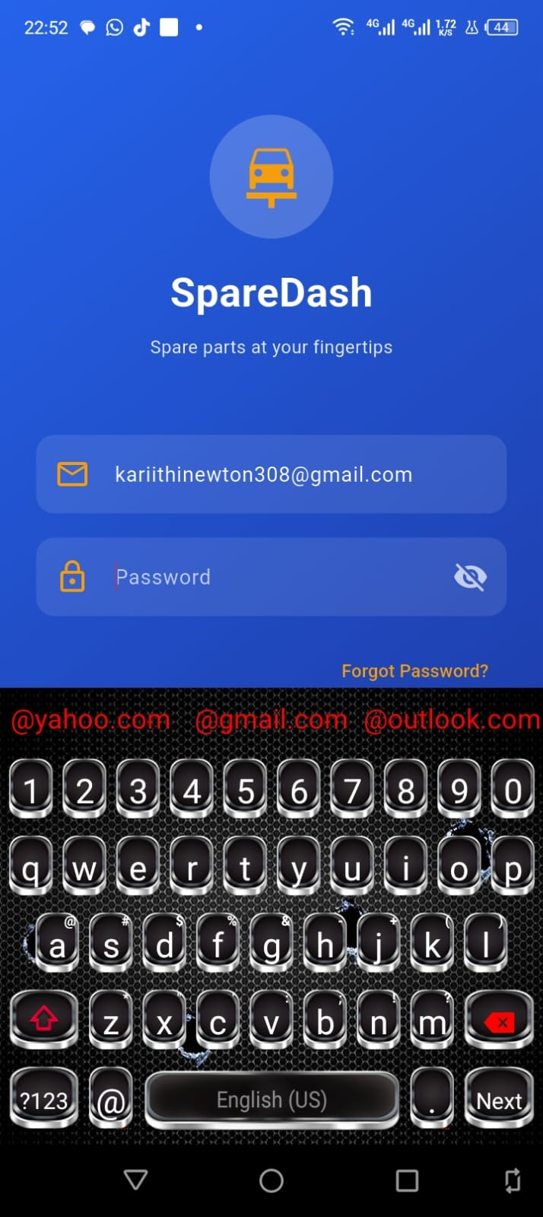

[SCREENSHOT: Fig 8.6 - Register screen keyboard chain]
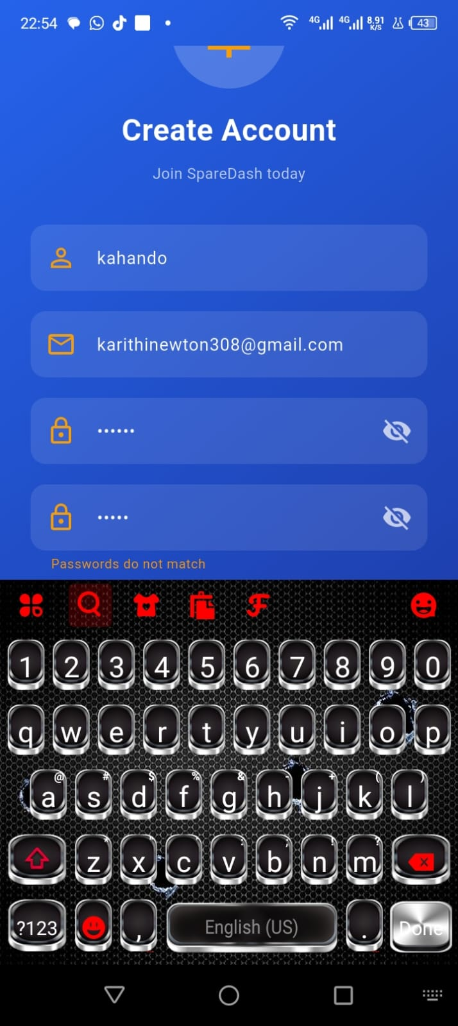

[SCREENSHOT: Fig 8.7 - Long press bottom sheet]
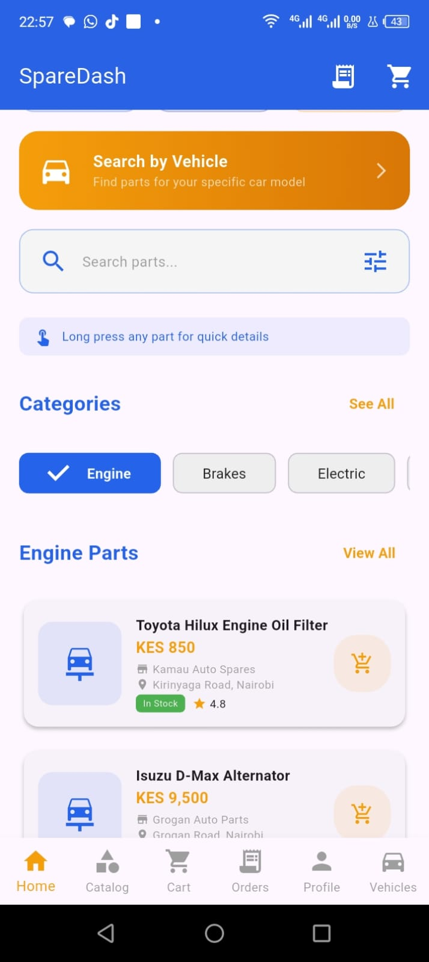

[SCREENSHOT: Fig 8.8 - Swipe to delete cart item]
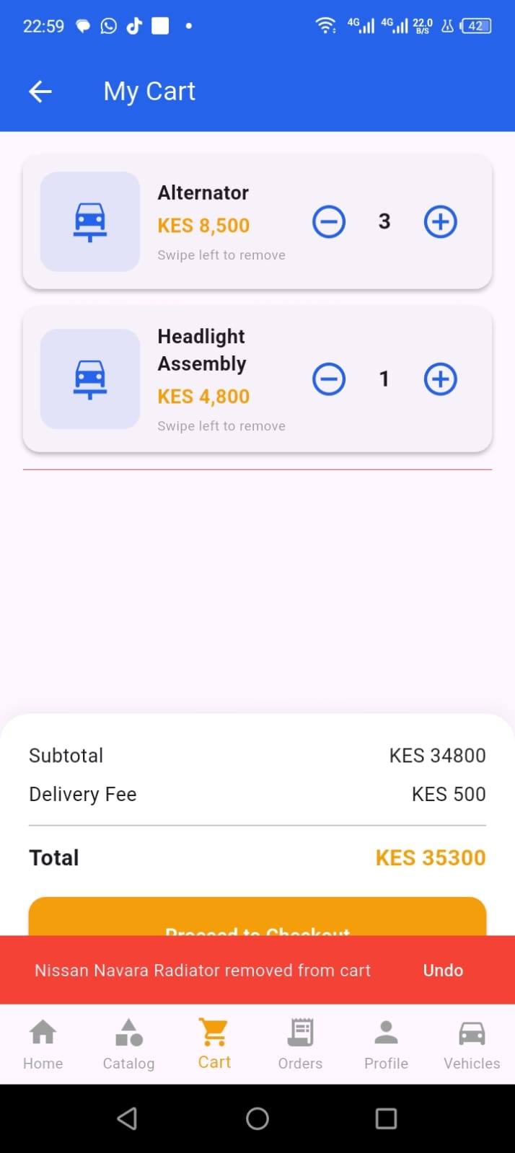

[SCREENSHOT: Fig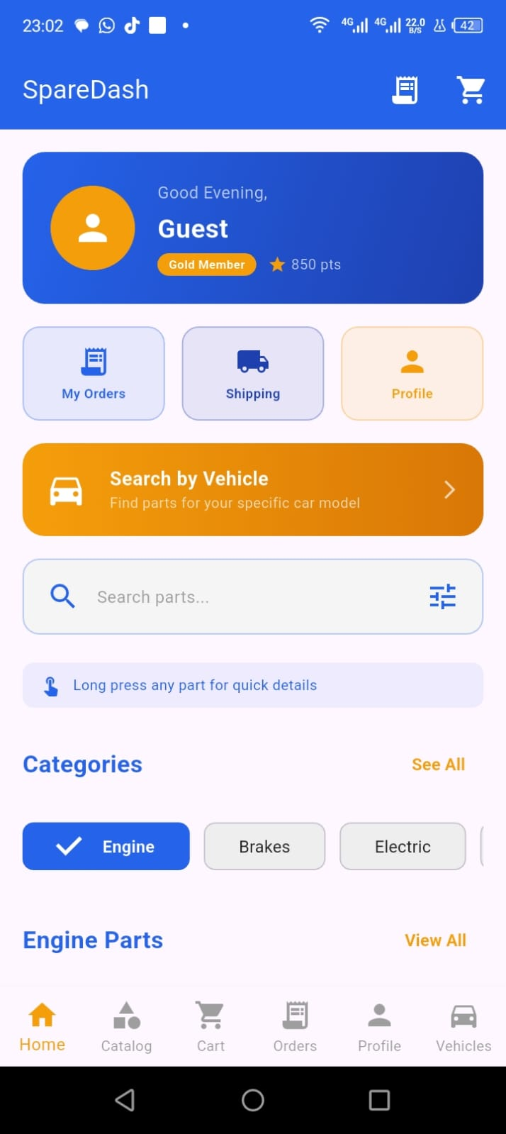 8.9 - Long press hint banner]

Tools / Software Used
IDE | Android Studio Narwhal (2025.3.4)
Flutter SDK | Flutter 3.44.2
Dart SDK | Dart 3.12.2
Test Device | INFINIX X669 (Android, USB debugging enabled)
Widgets Used | GestureDetector, Dismissible, FocusNode, ModalBottomSheet, TextInputAction
New Classes | ValidationService, InputHandler, GestureHandler (all in lib/services/)
Version Control | Git (Android Studio built-in)

Challenges & Solutions
Challenge | Solution
register_screen.dart was overwritten with login_screen.dart content | Re-wrote register_screen.dart from scratch with correct class name, imports, and InputHandler integration
Swipe dismiss removed item but cart provider still showed it | Used cart.updateQuantity(item.id, 0) inside onDismissed to properly sync the CartProvider state
Keyboard Done action on password field not submitting form | Used InputHandler.handleKeyboardAction() with action: TextInputAction.done and onSubmit: _validateAndLogin callback
Long press bottom sheet needed part details from SQLite | Passed part data as a Map<String, String> directly from _buildPartCard parameters into GestureHandler.onLongPress()

Personal Reflection
Week 8 elevated SpareDash from a functional app to a polished, gesture-aware product. The OOP refactor — separating ValidationService, InputHandler, and GestureHandler into dedicated classes — makes the codebase maintainable and demonstrates real software engineering practice. Swipe-to-delete and long-press details are features Kenyan users expect from modern apps like Jumia and Glovo.

Logbook Sign-off
Student Name | Newton
Student Signature | ________________________
Date Submitted
Lecturer Name | ________________________
Lecturer Remarks | ________________________
Date Reviewed

